Faculty Training  Navajo Technical College  April 9, 2009  Dr. Marsha Fralick  marsha.fralick@gcccd.edu |  | 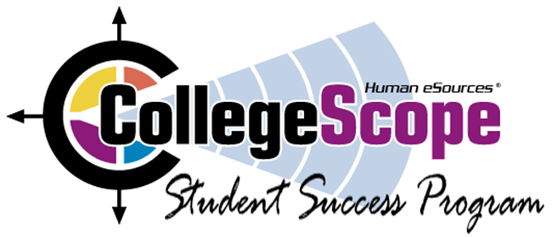
_____________________________________________________________________________________
http://www.collegesuccess1.com
Resources Include:
Faculty Training Notes for Navajo Technical College (Bottom of Page)
PowerPoint Presentation
Exercises
Freshman Year Experience Research article: “Exploring the Evidence: Initiatives in the First College Year”
Instructor Manual (500 pages of classroom exercises)
PowerPoint for College and Career Success
Test Bank (Information for Requesting)
Do What You Are User’s Manual and Psychometric Report
Tips for Faculty Using College and Career Success
Journal Entries (Word Documents for Students)
Research Articles
Video Clips
Resources for Online Teaching
Resources for Students
Internet Links for Each Chapter
And much more . . . .

