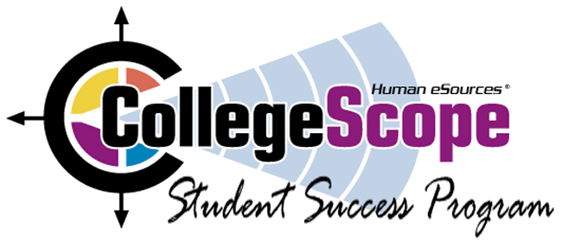
Skills Checklist
Place a checkmark to the left of each item as you complete it.
I can:
____1. Log into my account at http://www.collegescope.com/lonestar Use your email address
and the password you created.
____2. Read my assessment results.
____3. Find the career database. Open DWYA and click on a career at the bottom of the page.
____4. Add Sample Student to My Students. Click on Search. Type in: Student
Click on the Add to Me box next to Student, Sample.
____5. Go back to your faculty menu and click on My Students. You will only see Sample
Student.
____6. Find a chapter. Click on Sample Chapters. You will be assigned to survey a chapter.
What did you find in this chapter that was important for student success?
____________________________________________________________________
____7. Find the Do What You Are Counselor Handbook.
____8. Find the phone number for Customer Service.
____9. Go to the student website at http://www.collegescope.com/ccs/lonestar
What is the difference between the faculty and student URL? (Hint: 3 letters) Find the
student registration page. Click on Registration to view it. At the student site, log in as
Sample Student. (sample_student@lonestar.edu) (Note this is sample_student)
(password: sample1) View the student menu.
____10. Go to http://www.collegesuccess1.com Click on Instructor Manual. Click on any
chapter and skim contents. Go back to the home page. Click on Faculty Resources.
Click on Videos and skim contents.

