Student Success Faculty Training  Montgomery College  August 5, 2010, 8:30-4:30  Dr. Marsha Fralick  marsha.fralick@gcccd.edu  http://www.collegesuccess1.com | 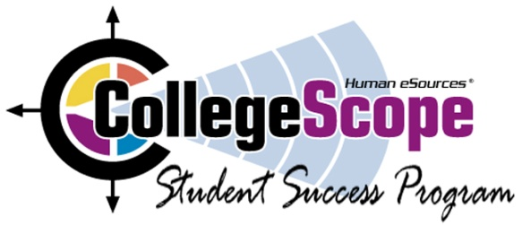

New Faculty 8:30-4:00, Room F-216, F224 (LSC-M)
Lunch 1:00-2:00
Continuing Faculty 2:00-4:00 F-224 (LSC-M)
New Faculty
Overview of CollegeScope (In Computer Lab F-216)
Using technology with New Millennial students, logging in and becoming familiar with your account features, introducing CollegeScope to your students, helping students log in, resources for faculty and students at http://www.collegesuccess1.com, research on student success (brief), keys to success, CollegeScope features, improving retention in the first critical weeks, what to do in the first 2 weeks
Snack Break (approximately 10:30)
Do What You Are personality assessment (in Classroom F-224)
Theory
Interpretation
Practical Classroom Exercises
PEPS learning style inventory
What is learning style?
Interpreting and using the PEPS
Learning Style Exercise
Tips for engaging students in learning (Theory and practical exercises)
Lunch 1:00-2:00 for New and Continuing Faculty
New and Continuing Faculty
Walking Through the Bamboo Forest: A relaxation exercise for test preparation and test anxiety
Career Trends of the Future
Grading Rubric and Weights (Discussion led by Montgomery faculty)
Share Your Creative Ideas. What has worked well for you?
Workshop evaluation
_____________________________________________________________________________________Login Address for Faculty
http://www.collegescope.com/lonestar
Login Address for Students:
http://www.collegescope.com/ccs/lonestar
Sample student: sample_student@lonestar.edu (Password: sample1) (Note: sample_student)

