Student Success Course
Description of Current Status
Goal: Develop a student success course for developmental math and other at-risk students to increase student success in developmental program completion, transition to credit classes, completion of gatekeeper classes and fall-to-fall retention.
Current Status: Multiple sections of the student success course (EDUC 1300) are now offered at every campus. 416 students were enrolled in the fall 2008 semester.
Timeline: Pilot timeline: spring ’08 – spring ‘10
Full implementation: fall ’10

Selected Analysis of Fall 2008 Activities
- LSCS offered a total of 20 sections for a total of 416 student enrollments
- Success Rate: 63% (n=263) were successful, completing the course with an A,B, or C
- Retention Rate: 90% (n=374) were retained

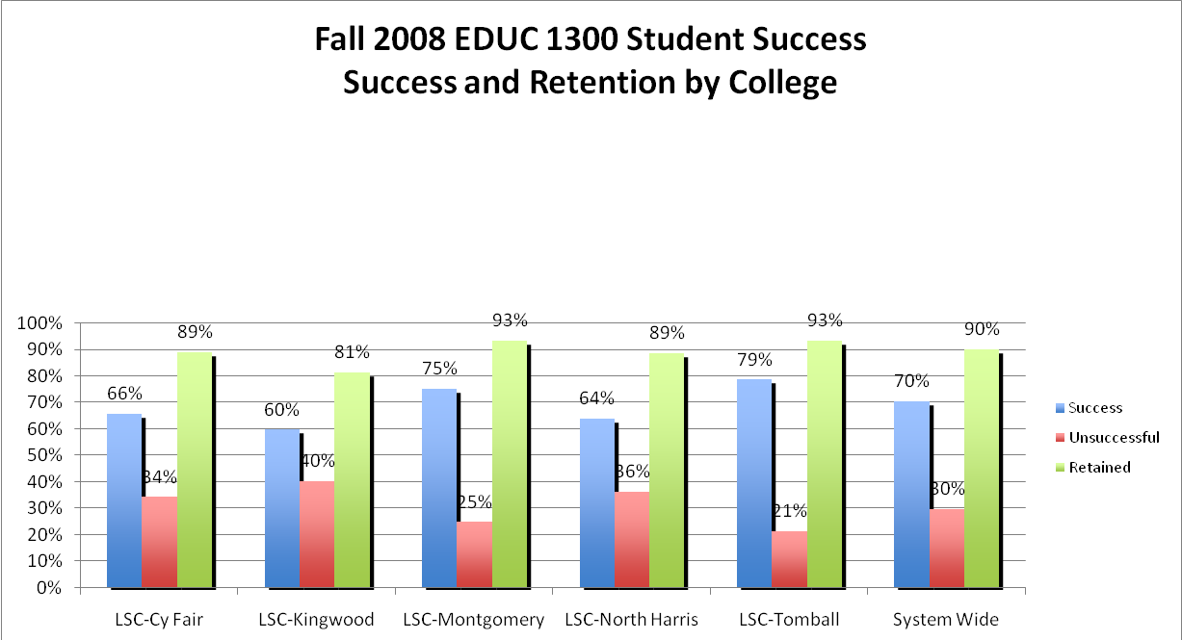
- Persistence Rate: 75% (n=312) is the overall persistence rate of those that were successful, unsuccessful or withdrawn.
College | Persistence rate of students who were successful | Persistence rate of students who were unsuccessful | Persistence rate of those students that withdrew (W) | Persistence rate of all Student Types
LSC – CyFair | 94% | 52% | 78% | 79%
LSC – Kingwood | 82% | 61% | 38% | 67%
LSC –Montgomery | 88% | 57% | 25% | 77%
LSC – North Harris | 90% | 71% | 67% | 81%
LSC – Tomball | 82% | 50% | 0% | 70%
System Average | 87% | 58% | 42% | 75%

