Student Success New Faculty Training  Lone Star College System  July 16, 2009, 8:30-4:00  Dr. Marsha Fralick  marsha.fralick@gcccd.edu  http://www.collegesuccess1.com | 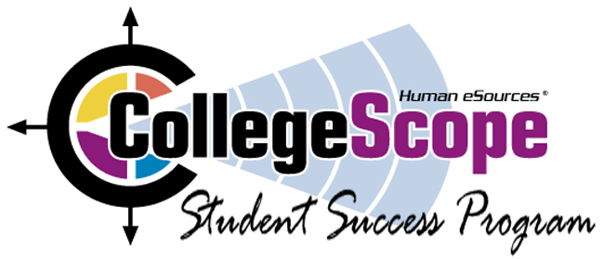
_____________________________________________________________________________________Ice Breaker
Resources for faculty and students at http://www.collegesuccess1.com
CollegeScope
Overview and Features
Research on student success
Using Technology with New Millennial Students
Logging in
Do What You Are personality assessment
Theory
Interpretation
Practical Classroom Exercises
PEPS learning style inventory
What is learning style?
Interpreting and using the PEPS
Learning Style Exercise
Lunch 12-1
Using CollegeScope to improve retention in the first critical weeks
Helping students log in
Tips for engaging students in learning (Theory and practical exercises)
Workshop evaluation
_____________________________________________________________________________________Login Addresses for Faculty
Cy-Fair Community College: http://www.collegescope.com/cy-fair
Kingwood Community College: http://www.collegescope.com/kingwood
Montgomery Community College: http://www.collegescope.com/montgomery
North Harris Community College: http://www.collegescope.com/northharris
Tomball Community College: http://www.collegescope.com/tomball
Sample student: sample_student@cy-fair.edu (Password: sample1) (Note: sample_student)

