Student Success New Faculty Training  Lone Star College System  December 10, 2009, 8:30-3:30  Dr. Marsha Fralick  marsha.fralick@gcccd.edu  http://www.collegesuccess1.com | 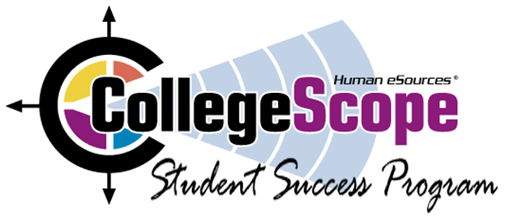
_____________________________________________________________________________________ 8:30-9:45 The CollegeScope Student Success Program
Faculty and student Login
A quick tour
Introducing CollegeScope to your students
Using CollegeScope to increase retention and success
10:00 CollegeScope (online) and College and Career Success (printed text)
Resources for faculty and students at http://www.collegesuccess1.com
Overview and Features
Research on student success
Do What You Are personality assessment
Theory
Interpretation
Practical Classroom Exercises
12-12:45 Lunch
12:45-3:30 Do What You Are personality assessment (continued)
PEPS learning style inventory
What is learning style?
Interpreting and using the PEPS
Learning Style Exercise
Tips for engaging students in learning (Theory and practical exercises)
Workshop evaluation
_____________________________________________________________________________________Login Addresses
Faculty http://www.collegescope.com/lonestar
Students http://www.collegescope.com/ccs/lonestar
Sample student: sample_student@cy-fair.edu (Password: sample1) (Note: sample_student)

