Student Success New Faculty Training  Lone Star College System  January 13, 2010, 9:00-4:00  University Center, Room 208  Dr. Marsha Fralick  marsha.fralick@gcccd.edu  http://www.collegesuccess1.com | 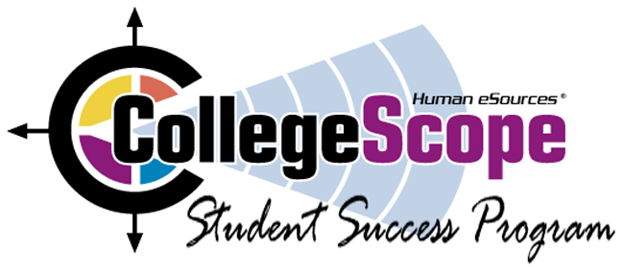
_____________________________________________________________________________________Ice Breaker
Resources for faculty and students at http://www.collegesuccess1.com
CollegeScope/College and Career Success
Overview and Features
Research on student success
Using Technology with New Millennial Students
Logging in
Do What You Are personality assessment
Theory
Interpretation
Practical Classroom Exercises
PEPS learning style inventory
What is learning style?
Interpreting and using the PEPS
Learning Style Exercise
Lunch 12-1
Using CollegeScope/College and Career Success to improve retention in the first critical weeks
Helping students log in
Tips for engaging students in learning (Theory and practical exercises)
Workshop evaluation
_____________________________________________________________________________________Login Address for Faculty
http://www.collegescope.com/lonestar
Login Address for Students:
http://www.collegescope.com/ccs/lonestar
Sample student: sample_student@lonestar.edu (Password: sample1) (Note: sample_student)

