Getting Started with CollegeScope
Faculty Training Guide
Dr. Marsha Fralick
Prepared for Lone Star College System

This guide provides step-by-step instructions for navigating Human eSources’ CollegeScopeTM Student Success Program, getting the most from the program and helping your students improve retention and success.
Step 1: Set up your account.
Contact Dr. Marsha Fralick (marsha.fralick@gcccd.edu) to set up your account. In your email, provide your name and the email address you wish to use for your account. You will be contacted as soon as the account is created and I will provide you with log in instructions, including a temporary password.
Note that the system will automatically send you an email with a temporary password and log in instructions. This email often winds up in a spam folder or lost due to email server security settings. If you do get an automated email, just ignore it. I have solved the problem of lost emails by sending a personal email to you with instructions and a temporary password. The temporary password is: banana
Step 2: Log in.
Go to www.collegescope.com/lonestar to begin the log in process. Use your email address and assigned password (banana) to log in. Do not click on Register Here.
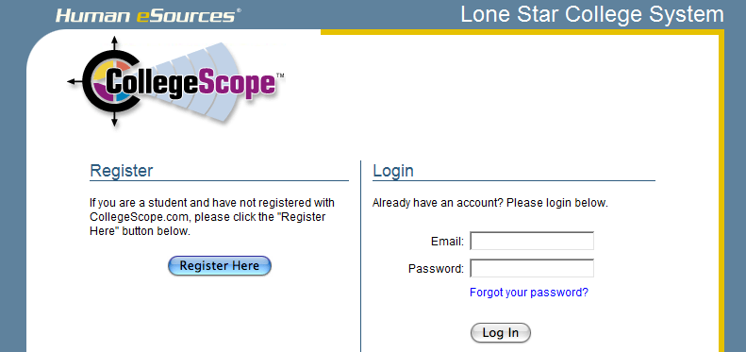

Step 3: Update your account.
When you enter your email address and temporary password, you will be asked to update your account. Create your own password and security question at this point.
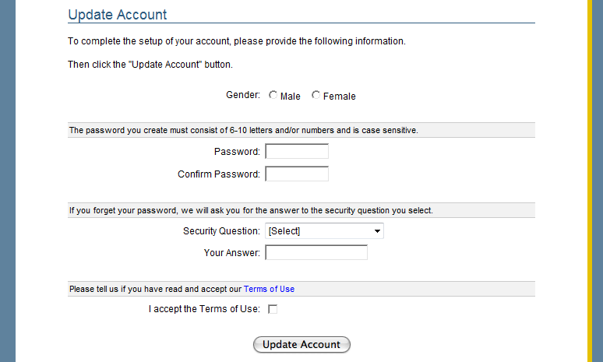
Step 4: View your home page and the main menu.
Next you will see your Home Page and be able to view your Main Menu.
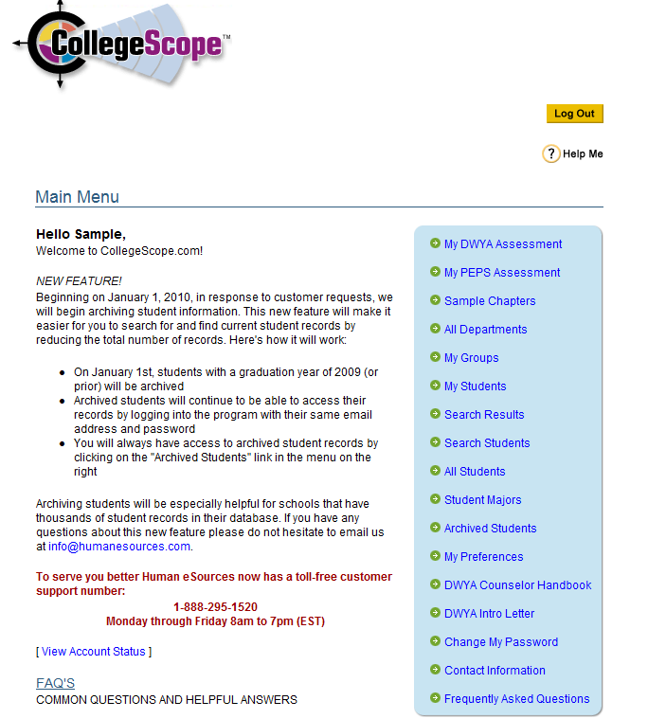
Step 5: Complete Do What You Are (DWYA).
Read the directions for completing the assessment, click on My DWYA Assessment and complete the personality assessment. The following directions are the same ones that you will provide to your students.
Directions:
- Personality type is a theme used throughout the Student Success Program. It is important that the assessment results are accurate. Choose a time for the assessment when you are not tired or rushed to complete it. The knowledge you will gain from this assessment will be valuable for the rest of your life.
- This assessment is not a test! There are no right or wrong or good or bad answers to the questions on DWYA. Each person has a unique personality with their own gifts and talents. Knowing your gifts and talents will be helpful in understanding yourself and selecting your college major.
- This assessment does not measure psychological or emotional health or intelligence.
- Be honest with your answers and answer them according to how you usually are when you are not stressed. Do not answer the questions:
  - How you want to be
  - How you have to be at work or at home
  - How others want you to be
- Do not take too long on each question or overanalyze them. Answer what comes to mind first.
Step 6: Complete the Career Interest Survey.
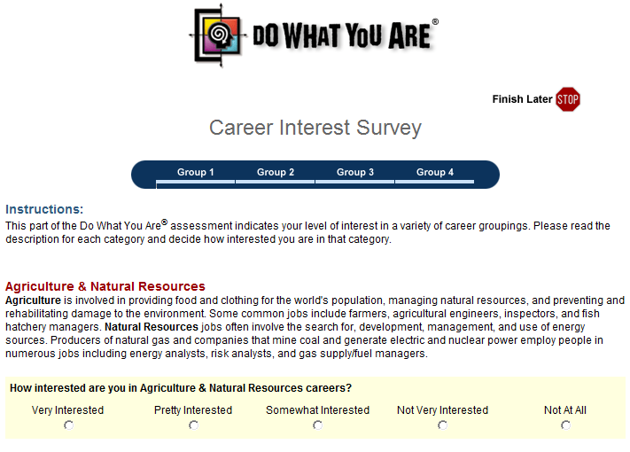

Read your report when you finish the assessment. Be sure to click on some careers at the end of the report to see the career information that is available to your students. You can also access your report from the Faculty Menu on your Home Page.
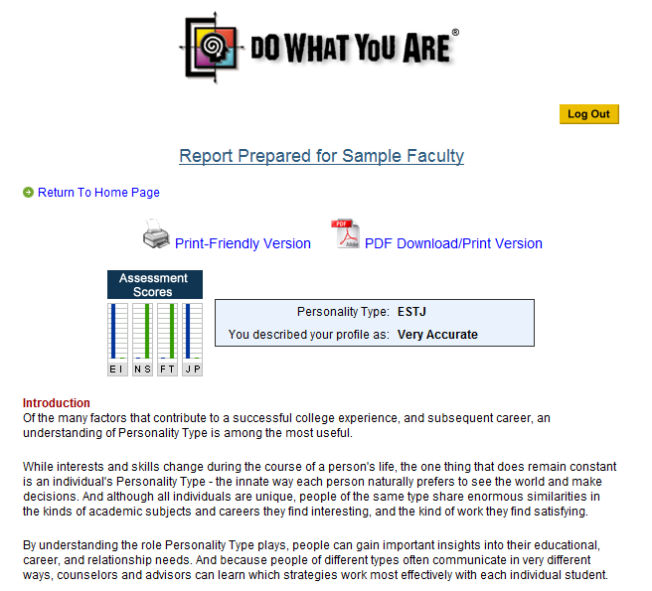
Step 7: Complete the PEPS Learning Style Inventory.
Return to your Home Page. Read the directions for taking the PEPS Learning Style Inventory. These are the same ones you will provide to your students. Click on My PEPS Assessment and complete the inventory.
Directions:
The inventory consists of 100 rating items. Most students will complete the PEPS Learning Style Inventory in 20-30 minutes. It is recommended that students take the assessment when they are not tired and have plenty of time to complete it. Here are some points to stress when giving students directions for taking the PEPS Learning Style Inventory:
- Answer quickly by giving your initial response. There is no need to spend time analyzing each response.
- Answer as though you are learning new or difficult material.
- The inventory is not a test. There are no right or wrong answers. The inventory will help you to understand how you learn best.

Step 8: View your PEPS Report and your Summary Chart.
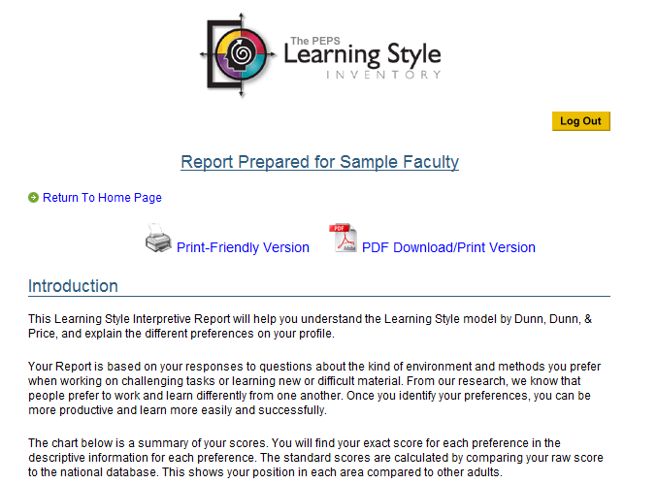
The areas in green indicate your preference. The gray areas are neutral.
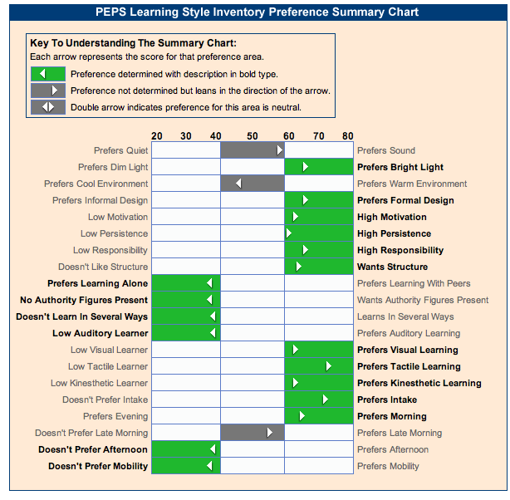
Step 9: View the Sample Chapters.
Return to your Home Page and skim through the sample chapters. Note that the chapters are personalized for students, but not for faculty.
Step 10: Add a sample student to My Students.
If you click on My Students, you will not find any students there yet. We are going to search for an invented student that we have named “Student, Sample” and then add this student to My Students. First, click Search Students on Your Faculty Menu and type in the student’s last name, “Student.” Second, click the Add button next to “Student, Sample.” Make sure to select the one with the Student ID, “sample1.” You will add students from your roster using this same method.
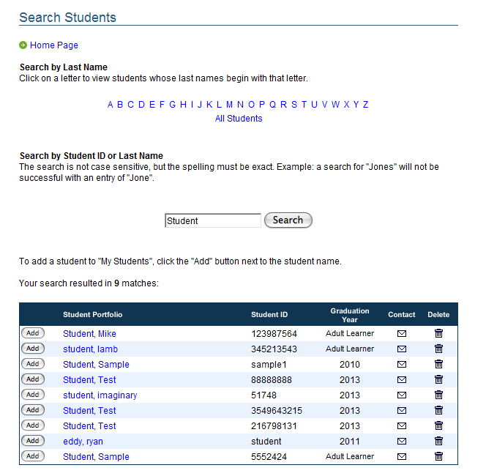
2

1
Note: If you cannot find this student, go to your Faculty Menu and click on Archived Students.
After 2 years, students are stored there.
Step 11: View a sample student portfolio.
Return to your Home page and click on My Students. Click on “Student, Sample.” View the Student Portfolio. You can show this sample portfolio to your students.
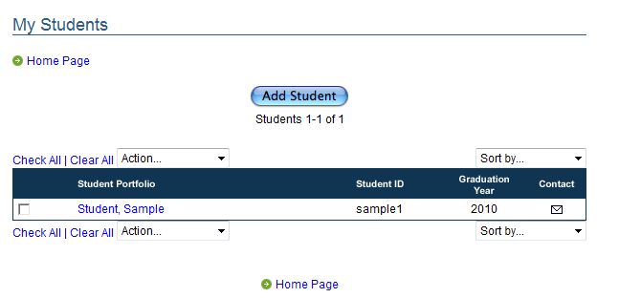
Click on His Chapters to see his quiz results and journal entries.
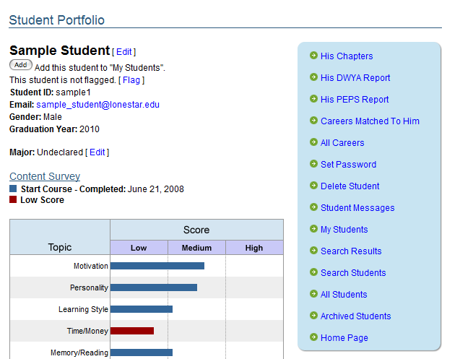
Click on a chapter title to see the student’s work.
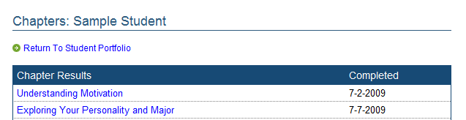
Here is sample student’s work:
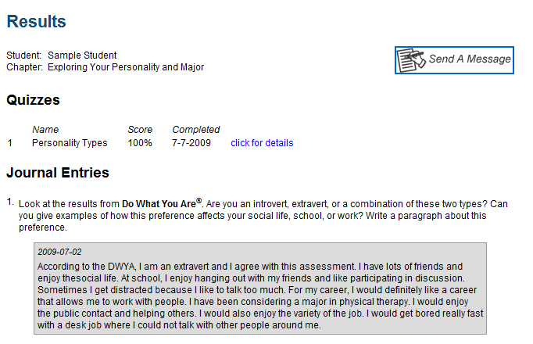
Step 12: Review the remainder of the Main Menu items.
Return to the Home Page and explore the other items on the Main Menu. You are off to a good start!
Step 13: Find additional resources.
To access supporting material for CollegeScope, go to www.collegesuccess1.com. When you arrive at this site, explore the Instructor Manual and Faculty Resources links. There are ove 500 pages of activities to engage students in learning, student handouts, videos, internet links and other useful material at this site.

Let me know if you have difficulties along the way. You can reach me at marsha.fralick@gcccd.edu or Human eSources’ Customer Support at 1-888-295-1520 or support@humanesources.com.

