Name\_\_\_\_\_\_\_\_\_\_\_\_\_\_\_\_\_\_\_\_\_\_\_\_\_\_\_\_\_\_\_\_\_\_\_\_\_\_\_\_\_\_Date\_\_\_\_\_\_\_\_\_\_\_\_\_\_\_\_\_\_\_

C:\Users\Marsha\Pictures\Microsoft Clip Organizer\ed00218_.wmf

**My Personal Strengths Word Cloud**

Create a Word Cloud of your personal strengths using the results of your AchieveWorks Personality Assessment. Follow these steps to create your Word Cloud.

1. Go to your e-text or career portfolio in the printed text and view your TruTalent Personality Assessment.

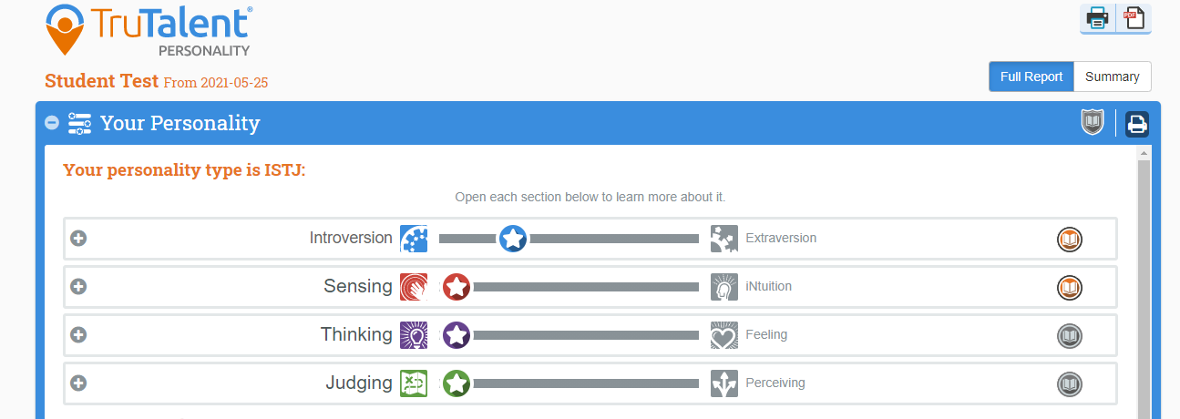

1. Read your Personality Profile and then click on the + Tab for each of these categories.

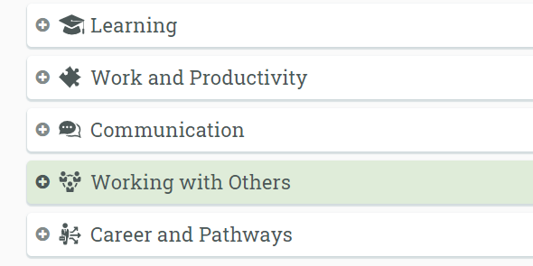

1. Here is an example:

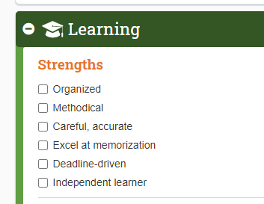

1. Use your Personality Profile and all the tabs above to **make a list of at least 25 of your personal strengths.** Add your own ideas to the list. Single words work best.

Here is an example: Organized, Productive, Accurate, Order, Stability, Punctual, Goals, Memory, Independent, Logical, Efficient, Self-Reliant, Reliable, Trustworthy, Honest, Listener, Rational, Direct, Responsible, Loyal, Likable, Accomplishment, Realistic, Logical, Fair, Patient, Humor, Creative, Contribute, Helpful, Caring, Experienced

1. Go to WordClouds.com at <https://www.wordclouds.com/> This is a free site.

Click on File. Then Paste/Type Text.   
Paste your own list of personal strengths in the box.

Click Apply.  
Click on Shape and choose a shape. Click on Theme and choose your colors.

Go to File. Save as Image. Name your file. Save.   
Open file. Save as .jpg on your computer. Copy and paste your Word Cloud below.

Here is an example of a Word Cloud using the sample list above:

Your 25 personal strengths are:

Paste Your Word Cloud Here: