**My Superpowers Word Cloud**

Create a Word Cloud of your highest skills (superpowers) using the results of your TruTalent Skills Assessment. Being aware of your skills is helpful in choosing a major and career. Note that the assessment provides suggestions for improving your skills if needed to accomplish your career goals. Follow these steps to create your Word Cloud.

1. Go to your e-text and view your TruTalent Skills Assessment. Here is a sample:

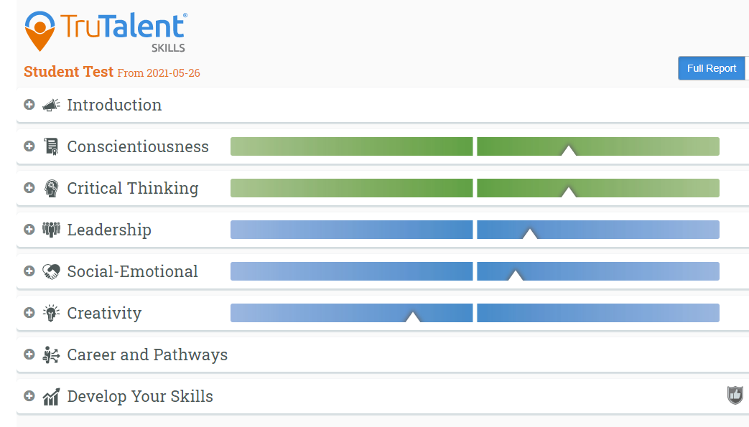

1. Click on the + Tab for each of these categories above and make a list of your highest skills.

On this assessment, my highest skills are thoroughness, organization, practicality, discipline, self-awareness, curiosity, achievement, confidence, resilience, influence, consideration, sincerity.

List your highest skills here:

In addition, I think I have these skills which would be valuable in the workplace: likeable, dedicated, loyal, friendly, honest, caring, humor, tolerant.

What additional skills do you have? Single words work best for this exercise. List your skills here:

1. Click on Careers and Pathways. List at least three careers that could be a good match for your skills.
2. Are there any skills you would like to improve? List them here:
3. Go to WordClouds.com at <https://www.wordclouds.com/> This is a free site.

Click on File

Paste/Type Text

Paste your list of personal strengths from #2 above in the text box.

Click Apply.

Click on Shape and choose a shape.

Click on Theme and choose your colors.

Go to File. Save as Image. Name your file. Save.

Open file. Save as.jpg on your computer.

Submit this file for your assignment or you can submit a screenshot.

1. Here is an example of a Superpowers Word Cloud using the words listed in #2. 