**Measure Your Success**

**Directions:** The following statements represent major topics included in the textbook. Read the following statements and rate how true they are for you at the present time. At the end of the course, you will have the opportunity to complete this assessment again to measure your progress.

5 Definitely True

4 Mostly true

3 Somewhat True

2 Seldom True

1 Never True

____I am motivated to be successful in college.

____I know the value of a college education.

____I know how to establish successful patterns of behavior.

____I can concentrate on an important task until it is completed.

____I am attending college to accomplish my own personal goals.

____I believe to a great extent that my actions determine my future.

____I am persistent in achieving my goals.

____Total Points for Motivation

____I can describe my personality type.

____I can list careers that match my personality type.

____I can describe my personal strengths and talents based on my personality

type.

____I understand how my personality type affects how I manage my time and money.

____I know what college majors are most in demand.

____I am confident that I have chosen the best major for myself.

____Courses related to my major are interesting and exciting to me.

____Total Points for Personality and Major

____I have a list or mental picture of my lifetime goals.

____I know what I would like to accomplish in the next four years.

____I spend my time on activities that help me to accomplish my lifetime goals

____I effectively use priorities in managing my time

____I can balance study, work, and recreation time.

____I generally avoid procrastination on important tasks.

____I am good at managing my money.

____Total Points for Managing Time and Money

____ I understand the difference between short-term and long-term memory.

____ I use effective study techniques for storing information in long-term memory.

____ I can apply memory techniques to remember what I am studying.

____ I know how to minimize forgetting.

____ I know how to use mnemonics and other memory tricks.

____ I know how to keep my brain healthy throughout life.

____ I use positive thinking to be successful in my studies.

____ Total points for Brain Science and Memory

____ I understand the latest findings in neuroscience and can apply them to studying.

____ I use a reading study system based on memory strategies.

____ I am familiar with e-learning strategies for reading and learning online.

____ I know how to effectively mark my textbook.

____ I understand how math is different from studying other subjects.

____ I have the math study skills needed to be successful in my math courses.

____ I take responsibility for my own success in college and in life.

____Total points for Brain Science and Study Skills

____I know how to listen for the main points in a college lecture.

____I am familiar with note taking systems for college lectures.

____I know how to review my lecture notes.

____I feel comfortable with writing.

____I know the steps in writing a college term paper.

____I know how to prepare a speech.

____I am comfortable with public speaking.

____Total Points for Taking Notes, Writing and Speaking

____I know how to adequately prepare for a test.

____I can predict the questions that are likely to be on the test.

____I know how to deal with test anxiety.

____I am successful on math exams.

____I know how to make a reasonable guess if I am uncertain about the answer.

____I am confident of my ability to take objective tests.

____I can write a good essay answer.

____Total Points for Test Taking

____I understand how my personality affects my communication style.

____I know how to be a good listener.

____I can use some basic techniques for good communication.

____I can identify some barriers to effective communication.

____I know how to deal with conflict.

____I feel confident about making new friends in college and on the job.

____I am generally a good communicator.

____I understand the theories of life stages.

____I can describe my present developmental stage in life.

____I have self confidence.

____I use positive self-talk and affirmations.

____I have a visual picture of my future success.

____I have a clear idea of what happiness means to me.

____I usually practice positive thinking.

____Total Points for Future

____I am confident of my ability to succeed in college.

____I am confident that my choice of a major is the best one for me.

____Total Additional Points

**Total your points:**

____ Motivation

____ Personality and Major

____ Managing Time and Money

____ Brain Science and Memory

____ Brain Science and Study Skills

____ Taking Notes, Writing and Speaking

____ Test Taking

____ Future

____ Additional Points

____ **Grand total points**

290-261 You are very confident of your skills for success in college. Maybe you do not need this course?

260-232 You have good skills for success in college. You can always improve.

231-203 You have average skills for success in college. You will definitely benefit from taking this course.

Below 202 You need some help to survive in college. You are in the right place to begin.

Use these scores to complete the Success Wheel that follows this assessment. Note that the additional points are not used in the chart.

**Success Wheel**

Name_______________________________Date_______________

Use your scores from the Measure Your Success Assessment to complete the following Success Wheel. Use different colored markers to shade in each section of the wheel.

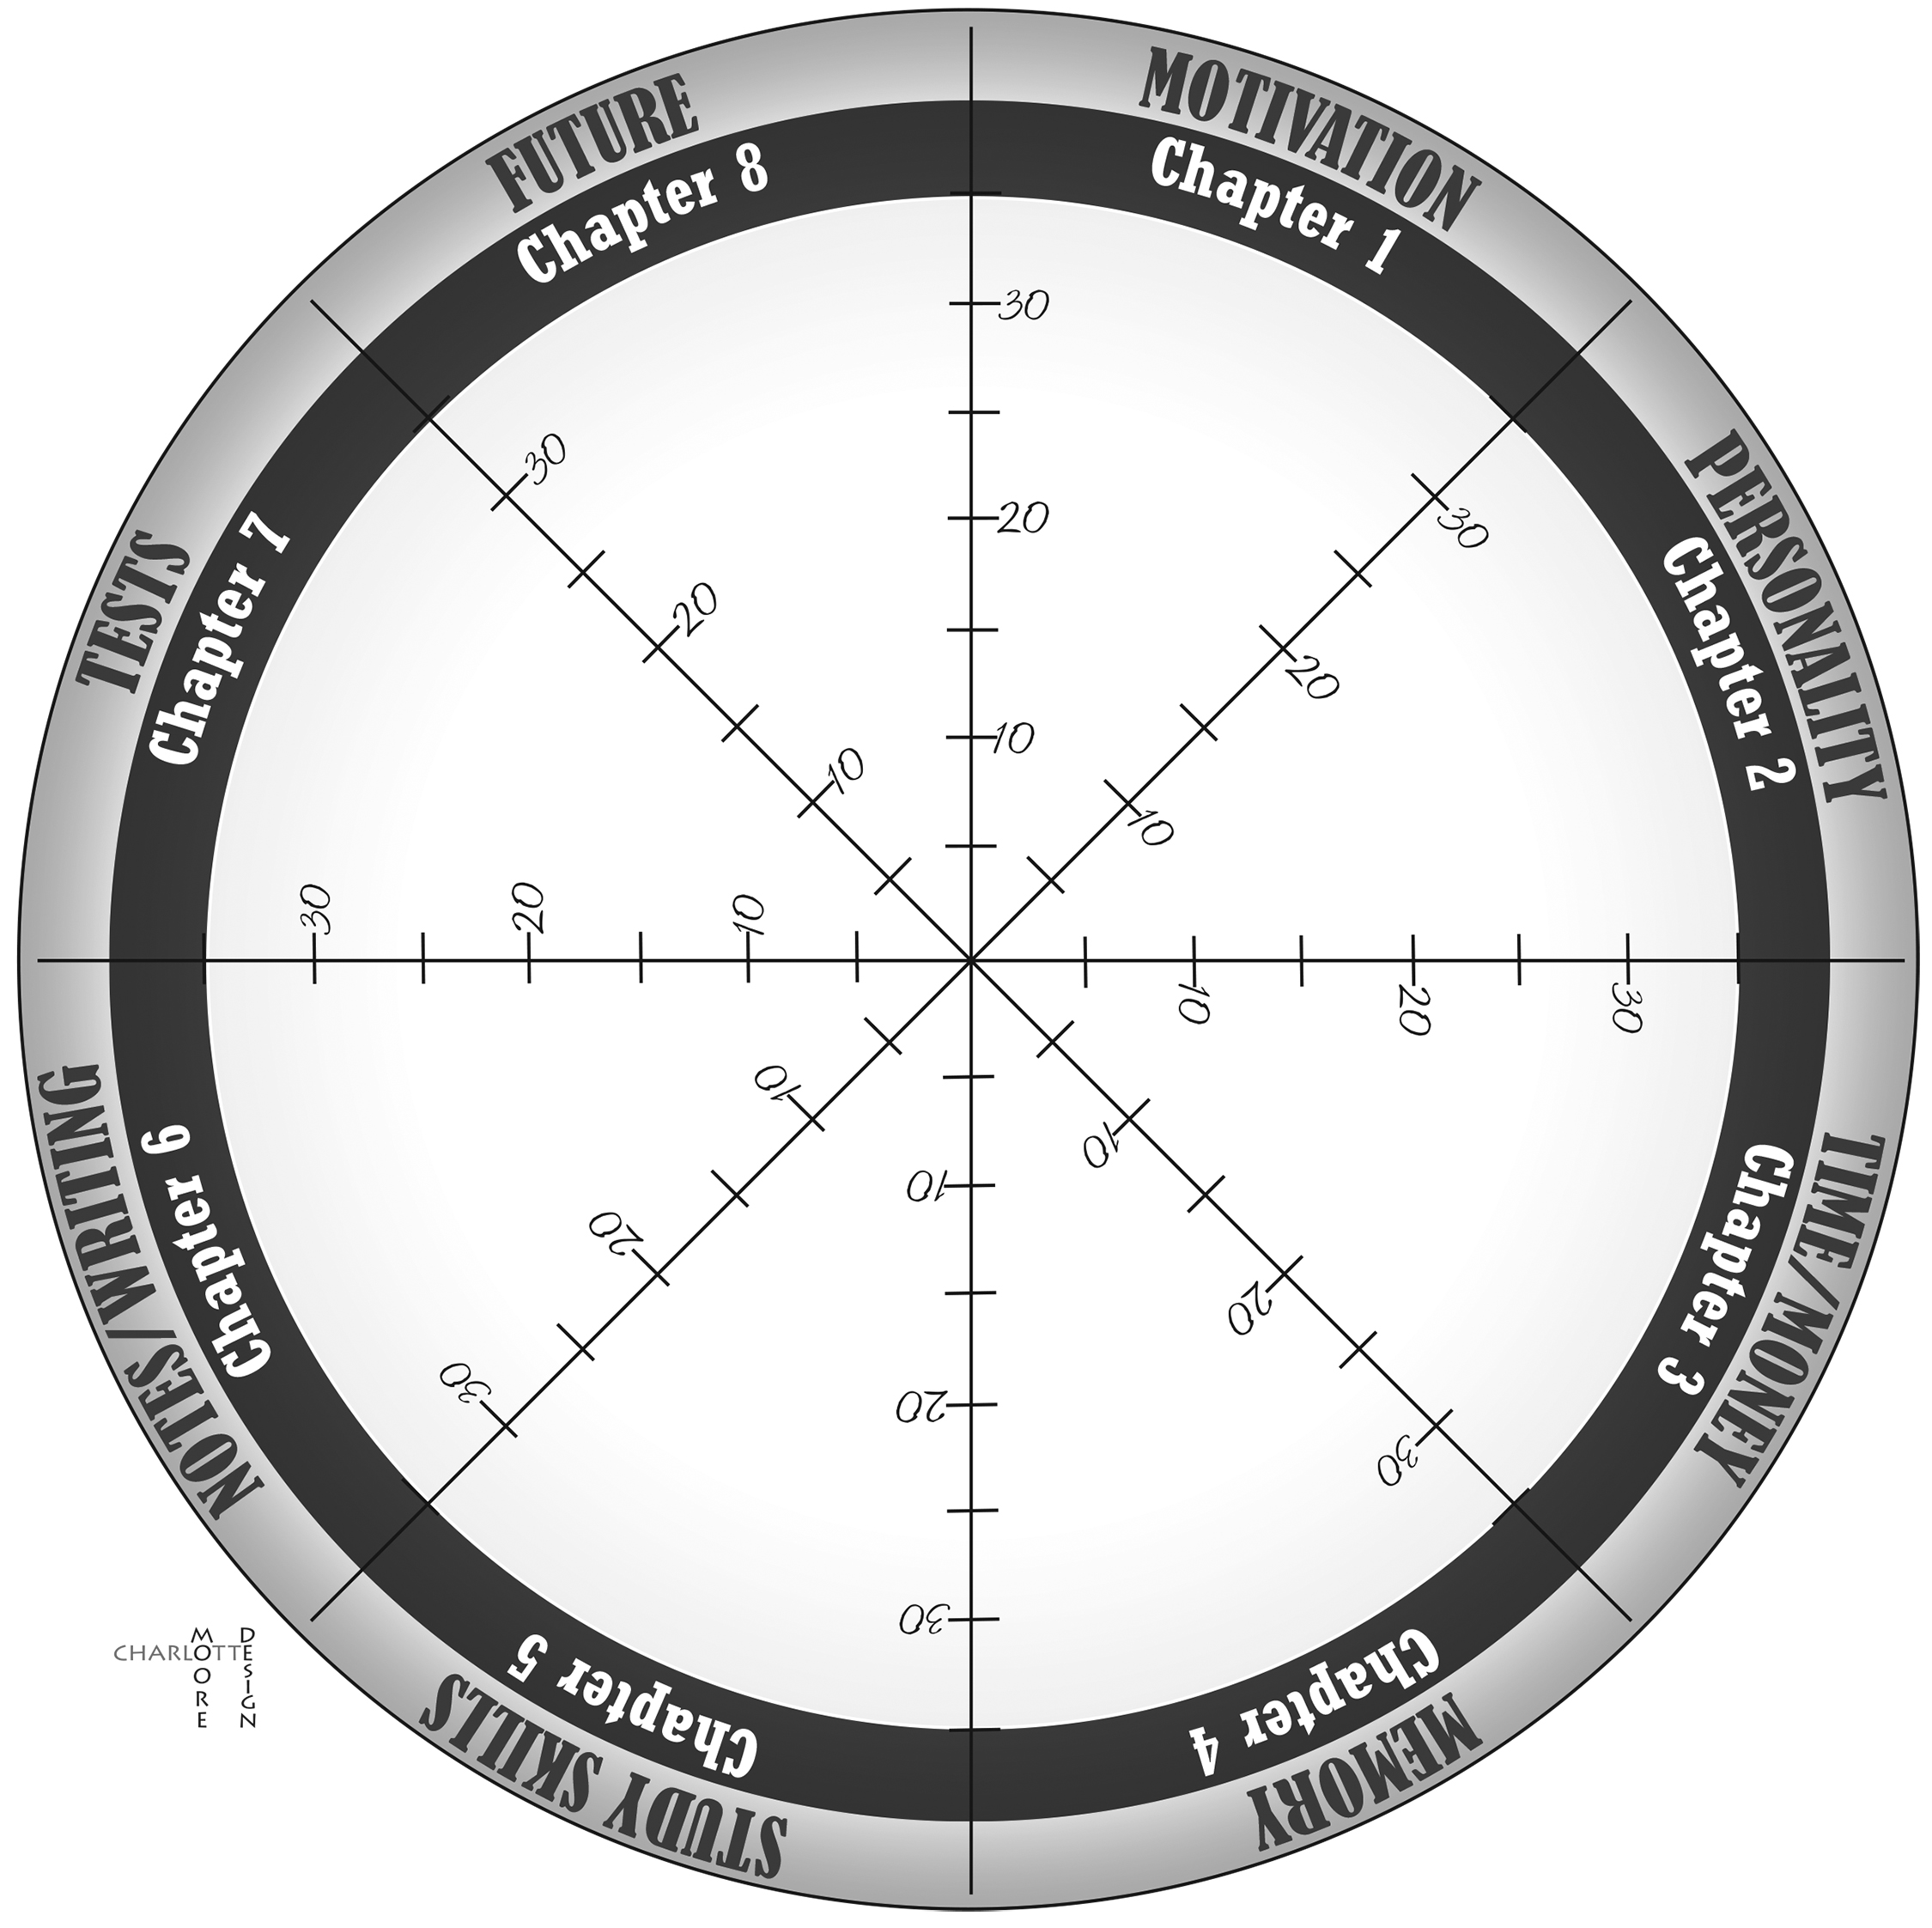

What are your best areas?

What areas need improvement?