Directions: Use your scores from Measure Your Success to complete this wheel.
Name__________________________________________Date___________________
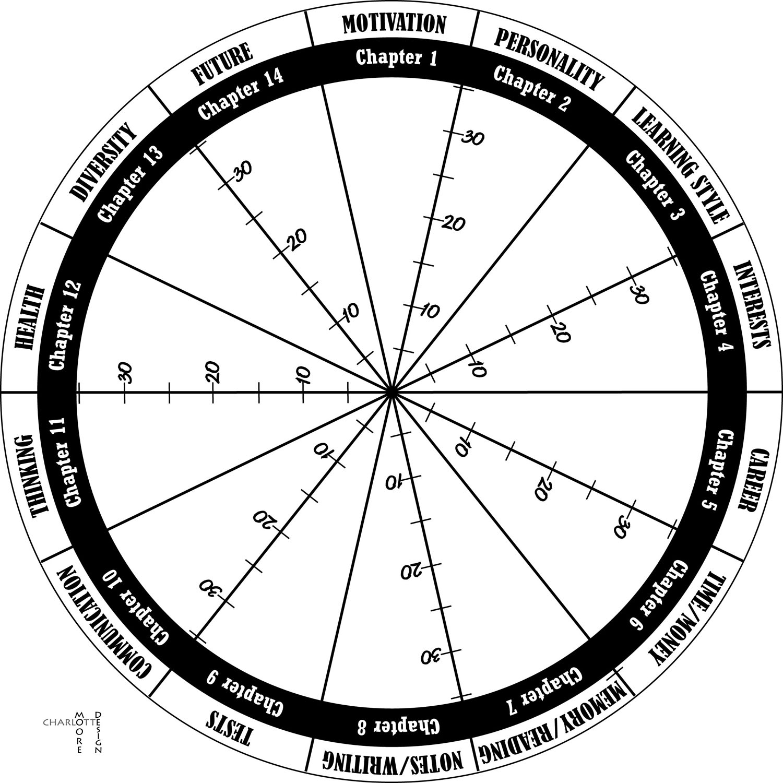
What are your best areas?
What areas do you need to improve?

