Health Improvement Assignment
Part I:
To assess your health habits, go to this site:
Living to 100 Life Expectancy Calculator at: https://www.livingto100.com/
Answer the questions to determine your longevity. The assessment also includes suggestions for improving your health. After you have finished the assessment, answer the following questions:
- How long are you expected to live based on your current health habits?
- What are some of your good health habits?

- List some future intentions for improving your health habits and extending your healthy life span.

Part II:
Go to www.choosemyplate.gov and look at all the resources for managing nutrition and exercise. Go to https://www.choosemyplate.gov/MyPlatePlan to find out your recommended calories per day. Then click on your recommended calories on the chart below to find recommendations for your food plan. Here is a sample from my plate plan:
Your MyPlate Plan:
1800 Calories

Below are the daily recommended amounts for each food group.
Click on the food group buttons to learn more and get started.
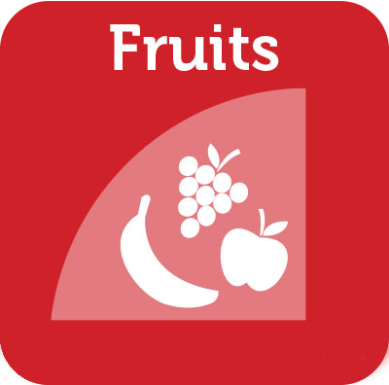 | 1 1/2 cups  1 cup from the Fruit Group counts as:  - 1 cup raw, frozen, or cooked/canned fruit; or  - 1/2 cup dried fruit; or  - 1 cup 100% fruit juice
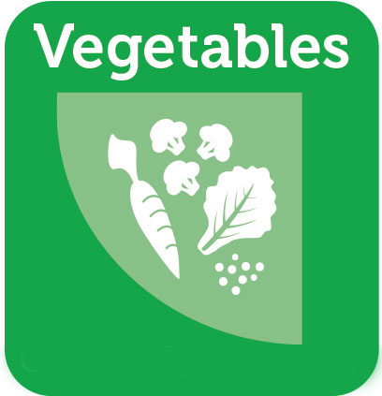 | 2 1/2 cups  1 cup from the Vegetable Group counts as:  - 1 cup raw or cooked/canned vegetables; or  - 2 cups leafy salad greens; or  - 1 cup 100% vegetable juice
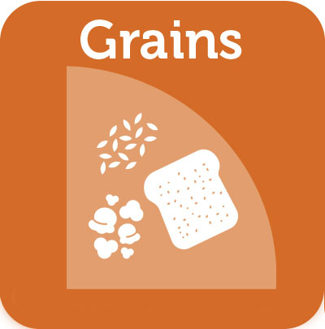 | 6 ounces  1 ounce from the Grains Group counts as:  - 1 slice bread; or  - 1 ounce ready-to-eat cereal; or  - 1/2 cup cooked rice, pasta, or cereal
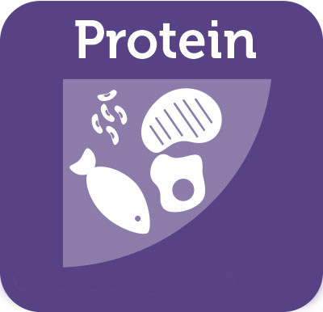 | 5 ounces  1 ounce from the Protein Foods Group counts as:  - 1 ounce cooked/canned lean meats, poultry, or seafood; or  - 1 egg; or  - 1 Tbsp peanut butter; or  - 1/4 cup cooked beans or peas; or  - 1/2 ounce nuts or seeds
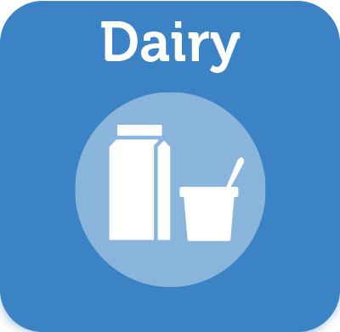 | 3 cups  1 cup from the Dairy Group counts as:  - 1 cup milk; or  - 1 cup yogurt; or  - 1 cup fortified soy beverage; or  - 1 1/2 ounces natural cheese or 2 ounces processed cheese
Copy and paste your food plan here:

What are some ideas from this exercise that you can use to improve your nutrition?

