College Success for the New Millennial Generation
Saturday, April 24, 8-9:00 a.m., Rooms 211/212
Dr. Marsha Fralick
Professor Emeritus, Cuyamaca College
marsha.fralick@gcccd.edu
Faculty Resources at http://www.collegesuccess1.com
Handouts and Exercises Posted at: http://www.collegesuccess1.com/Conferences.htm
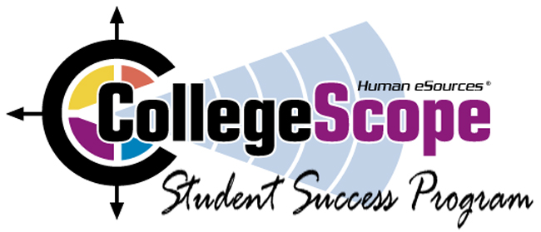  For a free demo of the e-text, contact Erin Miller: erinm@humanesources.com | 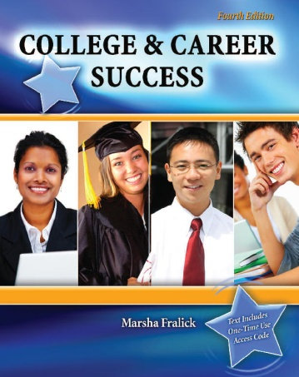 | For a complimentary text, email:  droth@kendallhunt.com

College Success  - Motivation  - Managing time and money  - Memory and reading techniques  - Test taking  - Note taking  - Writing and speaking | Career Success  - Exploring personality, interests, values, learning style and multiple intelligences  - Deciding on a major  - Career and educational planning  - Career trends of the future | Lifelong Success  - Communication and relationships  - Critical and creative thinking  - Healthy lifestyle  - Appreciating diversity  - Life stages  - Positive thinking

The Do What You Are personality assessment and the PEPS learning style inventory are included.
Free Resources
For resources on teaching college success, go to the College Success Website listed above. At this website you will also find the Instructor Manual with my best classroom exercises, faculty resources, research articles, PowerPoint presentations and resources for teaching online.

