Increase Motivation by Including Career Development in Your College Success Course
Sunday, February 6, 4:00-5:00 p.m., A 703

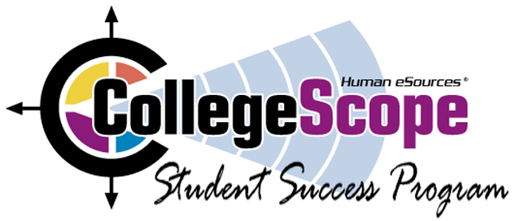  For a free demo of the e-text, contact Susie Wood: swood@humanesources.com | 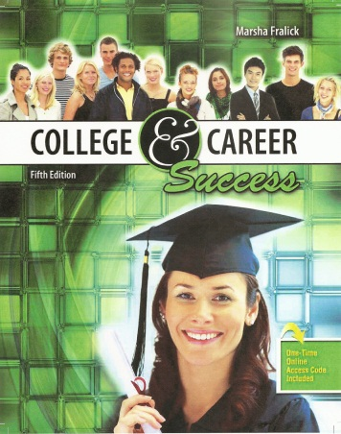 | For a complimentary text, email:  droth@kendallhunt.com

College Success  - Motivation  - Managing time and money  - Memory and reading techniques  - Test taking  - Note taking  - Writing and speaking | Career Success  - Exploring personality, interests, values, learning style and multiple intelligences  - Deciding on a major  - Career and educational planning  - Career trends of the future | Lifelong Success  - Communication and relationships  - Critical and creative thinking  - Healthy lifestyle  - Appreciating diversity  - Life stages  - Positive thinking
The Do What You Are personality assessment and the PEPS learning style inventory are included.
Free Resources
For resources on teaching college success, go to the College Success Website listed above. At this website you will also find the Instructor Manual with my best classroom exercises, faculty resources, research articles, PowerPoint presentations and resources for teaching online.

Dr. Marsha Fralick
Professor Emeritus, Cuyamaca College
marsha.fralick@gcccd.edu
Faculty Resources at http://www.collegesuccess1.com

